# Question 1

$\left\{a^{n}b^{m}a^{n+m} | n,m≥0\right\}$

This language is irregular. Let’s use the pumping lemma to prove it

Let p be an arbitrary number. Now let take the string s such that n=m=p

Then we have

$$a^{p}b^{p}a^{2p}$$

We have $\left|xy\right|≤p$ then $xy=a…a$

Then y is composed of a least on a as $\left|y\right|>0$

Now if we take $xy^{0}z$ we get $$a^{p-1}b^{p}a^{2p}$$

And we clearly see that $2p≠p-1+p$

So the pumping lemma show that the language is irregular

1. the set of all strings over {a,b} that do not have three consecutive as

This language is regular as we can build a DFA that recognize it.

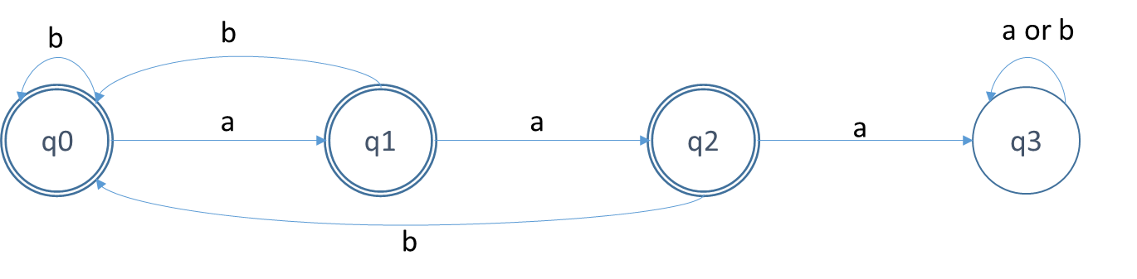

1. Palindromes:

This language is irregular. Let’s use the pumping lemma to prove it.

Let p be an arbitrary number. Let take the string s such that s is $a^{p}bba^{p}$

We have $\left|xy\right|≤p$ then $xy=a…a$

Then y is composed of a least on a as $\left|y\right|>0$

Now if we take $xy^{0}z$ we get $$a^{p-1}bba^{p}$$

We clearly see that this string is not a palindromes and thus this language is not regular

# Question 2

The language is irregular. Let use a counter example to show it’s not working in all case

Let take the language L ${\left(01\right)}^{n}$ this language is regular. We can easely make a DFA for it

Now $sort(L)$ is in fact $0^{n}1^{n}$ which is irregular

Then $sort(L)$ is not necessarily regular if L is regular

# Question 3

We can remove F and G as there cannot be reached

|  |  |  |  |  |  |
| --- | --- | --- | --- | --- | --- |
|  | A | B | C | D | E |
| A |  | ineq |  | Ineq |  |
| B |  |  | ineq |  | Ineq |
| C |  |  |  | Ineq |  |
| D |  |  |  |  | Ineq |
| E |  |  |  |  |  |

Using the minimization algorithm we see that we can merge A, C and E together, B and D can also be merge.

So the minimum automaton is

# 

# Question 4

All strings of the form $ab^{i}$ must be in distinct equivalent classes for all $i≥0$ as any to string $ab^{i}$ and $ab^{i^{'}}$ can be differentiate by $c^{i}$, since $ab^{i}c^{i}∈F$ and $ab^{i^{'}}c^{i}∉F$. But we have infinitely many equivalent classes of the indinguishability relation. By the Myhill-Nerode Theorem that no DFA can recognize $F$ and then $F$ is irregular

However the pumping lemma is working for this language

Let take p=2 we consider any string $x^{i}y^{j}z^{k}$ in the language

If $i=2 or i>2$ then we take $x=ϵ$ and $y=a$. If $i=1$, we must have $j=k$ (by the definition of the language) then adding a’s will conserve the membership in the language. For i > 2 all string $xy^{i}z$ have two or more a’s and then are always in the language. Now if we have $i=2$ we can keep $x=ϵ$ and now $y=aa$ then the string of the form $xy^{i}z$ always have a even number of a’s and thus belongs to the language.

The pumping lemma is not an ‘if and only if’ relation, it only say that it works for regular language but might also work for non-regular languages. Then having the pumping lemma work for a specific language does not mean anything

# Question 5

1. The sequence of transition 001 always get to the state A where the light blue is truned of then none of the states satisfies this test
2. Similarly as we get to the state A and the red light is on the all the states satisfies this test
3. We can differentiate A and C by checking if the blue light is turn on then the test ‘blue’ is failing for A but succeeds for C
4. We can differentiate B and C by checking the red light if it’s on then it’s C otherwise it’s B then the test ‘red’ make the difference
5. B and D both have the same color so we can’t differentiate using the color. Now if we use a 0 transition from B we end in C and the same for D and if we use a 1 transition then we finish in A for B and D then whatever we test we are going to get the same result for B and D